RSN Evaluator

It takes space separated postfix expressions as input and computes their value. It supports the following operands:

|  |  |  |
| --- | --- | --- |
| Operand Symbol | Operand Name | Type |
| + | Addition | Binary |
| - | Subtraction | Binary |
| * | Multiplication | Binary |
| / | Division | Binary |
| % | Percentage | Unary |
| ! | Factorial | Unary |

Requirements:

It is developed using Java 8 and maven is the build tool. Inorder, to compile the code maven 3.3(onwards) is recommended along with jdk 1.8. However, to simply run the project JRE 1.8 is sufficient.

Running the code:

The code can be run using 2 optional arguments.

Running the code with 2 arguments:

The first argument is the location of the input file. The input file contains space separated postfix expression. The second argument is the location of the output file. The output_file contains the post fix expression along with its value.

java –jar RPN-0.0.1-SNAPSHOT-jar-with-dependencies.jar input_file output_file

Input File:

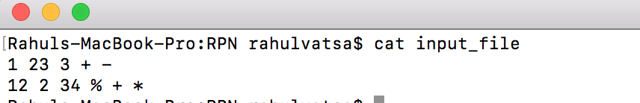

Running Code:

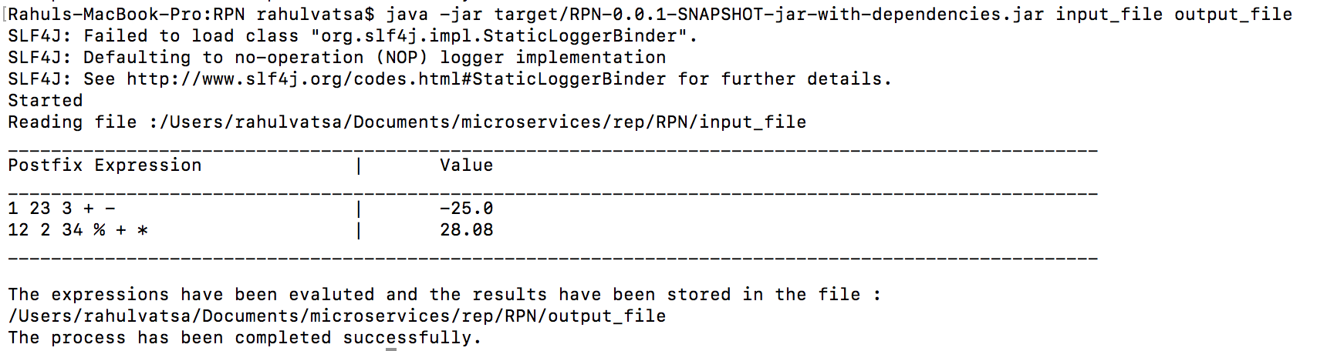

Output file:

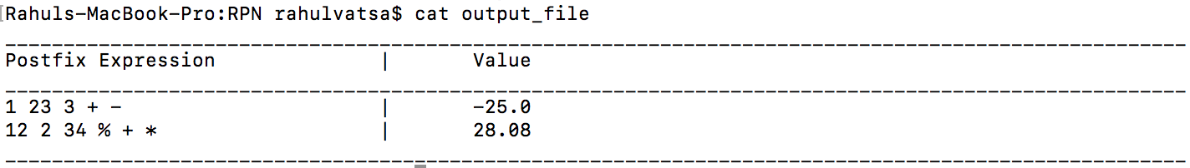

Running the code with 1 argument:

In this case only the input file is mentioned. The output file is simply the input file followed by “.evaluatedPostfix.txt”.

java –jar RPN-0.0.1-SNAPSHOT-jar-with-dependencies.jar input_file

Input File:



Running Code:



Output File:



Running the code with no arguments:

java –jar RPN-0.0.1-SNAPSHOT-jar-with-dependencies.jar

The user can enter a space separated postfix expression and the output will stored in a file named “evaluatedPostfix.txt”.

Running the code



Output file:



Entering an invalid postfix expression. The error is displayed on console and that expression is not added to output file.

